Learn to earn smart contract CORE Functionalities

# Native Currency

The native currency for the Learn2Earn smart contract is the **METIS** token

# Actors

1. Teachers
2. Students

# Functions (Teachers)

**Purchase Tokens**: - This action is performed by teachers. They send METIS to the smart contract and receive Education Tokens on the mapping of 1:100 or any mapping of our choosing.

**Set Test:** - Parameters for this action will be teachers address, test id and token reward X number of students. If the teacher’s token balance is greater than the token reward, the test would be set and tokens would be transferred from the teacher’s wallet to the smart contract. The new token balance of the teacher would be updated against the test id.

Withdraw Tokens :- teachers can withdraw remaining token balance.

# Functions (Students)

**Claim Test Reward:** - Parameters for this action will be student address, teacher address and test id. Tokens would be transferred from the smart contract to the student address and the teacher’s token balance updated against the test id taken by the student.

**Redeem Tokens: -** Students send in their tokens to the smart contract for a burn process and receive equivalent Ether in their address on that basis of 1:100 METIS-token mapping.

**Note : aside from the above core functionalities, the generated tokens would conform to ERC-20 token standard**

Connection Details For Metis network on Metamask for Rinkeby testnet

**Metis is a native token but also an ERC20 compatible token on Layer 2. Below is the configuration details for adding the network to Metamask**

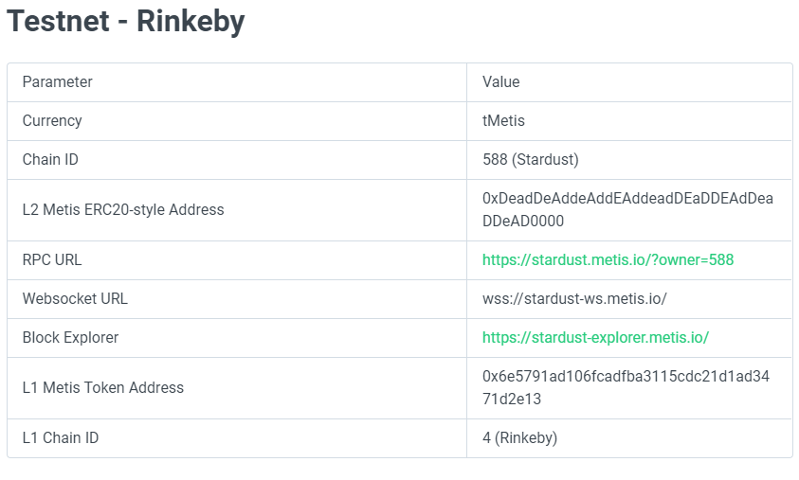

**Getting the metis Testnet tokens**

The metis testnet tokens can be gotten from this link <https://docs.metis.io/building-on-metis/getting-test-tokens>.

Metis Bridge

Bridging the metis tokens from layer1 of rinkeby to layer 2 of the metis network can be done following the link https://docs.metis.io/building-on-metis/metis-bridge